

B

Distance - 9.6 km

Climb - 150 m

Time (at 3km / hour) - 3 hr 30 mins

Map - Outdoor Leisure 41 at 1/25000

Description of Walk

A walk through woodlands, fields, country lanes and a short length of “C” road

Please take care when crossing roads and when near the river as the banks and boarded walkways can be muddy and slippy at times.

On a circular route only, B will be shown on the map as the start and finish point are the same location.

Given directions are only a general direction of travel for the overall leg and may vary on the ground

Directions

Start at Waddecar Grid Ref 559440

Follow the footpath adjacent to the River Brock to Weaver’s Farm GR 567451

Take footpath to junction at GR 573452

Go North to Hazlehurst at GR 570470

Carry on South West to reach the road near High Moor at GR 548452

Go South East along road to junction at GR 550446

Take field track South East, cross the River Brock and carry on up Snape Rake Lane turning left into Boggy Wood at GR 556440, finishing back at Waddecar Camp.

Km

0

0.2

0.7

1.5

2

3.3

4.3

5.7

7.4

9.3

9.6

Key;

A – Start/beginning

B – End/finish

1 – Km markings

1 – Direction of travel

A

B

PLEASE REMEMBER THE COUNTRY CODE

Direction

Start

North East

North

North East

North

North West

South West

South West

South East

North East

End

ETA (in min)

00:00

05:00

13:50

33:44

45:45

1:17:20

1:40:55

2:08:30

2:44:45

3:23:00

3:30:00



WALK 3 - Bleasdale Loop

Terrain Zero

ROUTE INFORMATION

LENGTH

9.678

Km

START

LAT:

53.890481,

LNG:

-2.671253

NOTES

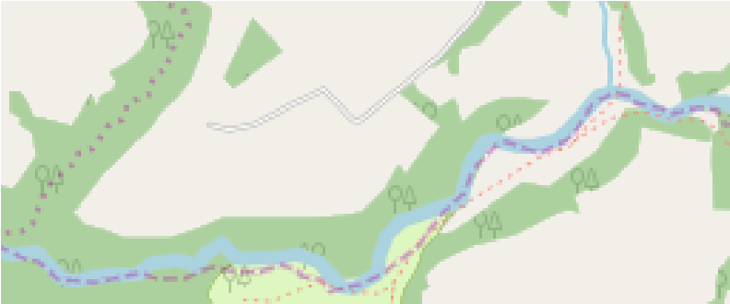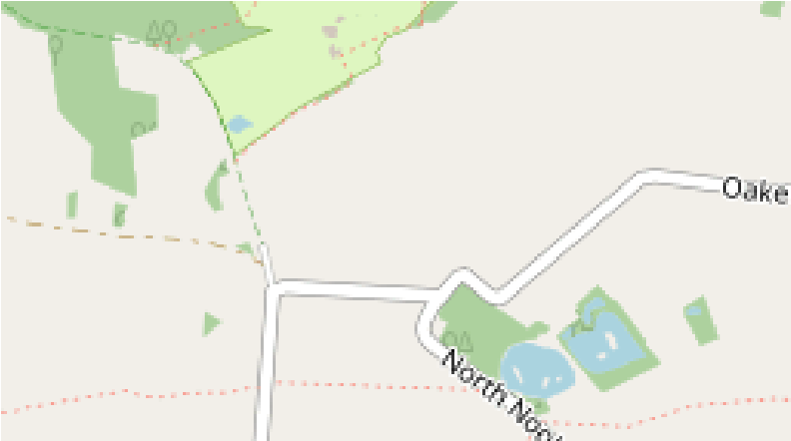

START

Map Data ©

OpenStreetMap Contributors

