

Key;

A – Start/beginning

B – End/finish

1 – Km markings

1 – Direction of travel

A

B



Walk 2 – Bleasdale Circle

Terrain Zero

ROUTE INFORMATION

LENGTH

3.255

km

START

LAT:

53.890516,

LNG:

-2.671130

NOTES

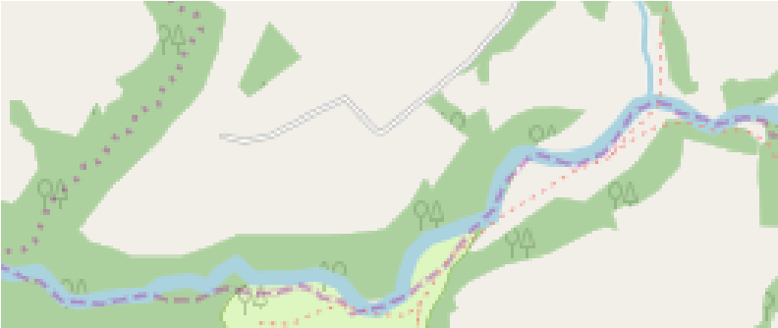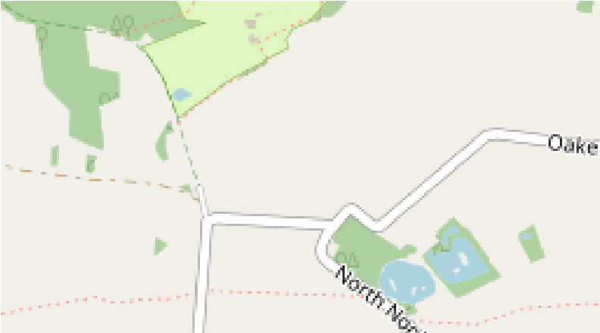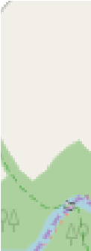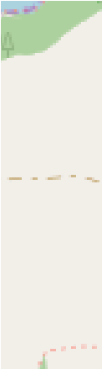

START

Map Data ©

OpenStreetMap Contributors

Distance - 6.7 km inc return

Climb - 60 m

Time (at 3km / hour) - 2 hr 20 mins

Map - Outdoor Leisure 41 at 1/25,000

A pleasant walk through woodland, alongside the River, then through fields and country lanes until you reach the site of the prehistoric wood circle of Bleasdale. The circle is thought to date from approximately 1000 years BC. The urns and parts of the circle timbers are in the Harris Museum in Preston. The position of the wood circle is now marked by concrete markers.

To the east it is possible to see Nick’s Chair as a dip on the ridge line of Blindhurst Fell.

Please take care when crossing roads and when near the river as the banks and boarded walkways can be muddy and slippy at times.

Given directions are only a general direction of travel for the overall leg and may vary on the ground

PLEASE REMEMBER THE COUNTRY CODE

Directions

Start at Waddecar GR 559440

Follow the footpath adjacent to the River Brock to Weaver’s Farm GR 567451

Take footpath to junction at GR 573452

Proceed North to Vicarage Farm at GR 574459

Go East on private land across field to Bleasdale Circle

Return by retracing the route

Direction

Start

North East

North East

North

East

North East

East

End

Km

0

0.15

0.69

1.28

1.41

1.62

2.96

3.16

ETA (in min)

00:00

02:16

06:39

15:09

15:59

21:32

32:46

36:07

