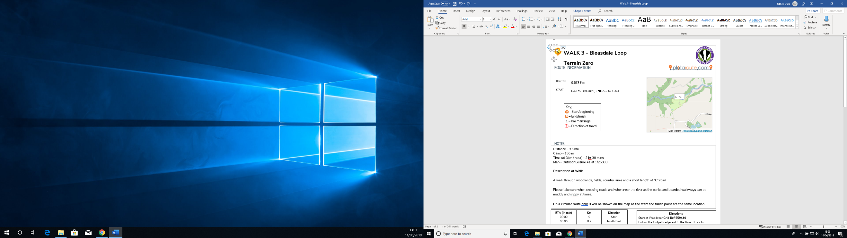

Route Description

Grid ref’s;

Start – 559 440, Follow the footpath that runs alongside the river Brock and over to Wickins Barn (573 441). Follow the road until you meet a footbridge to your right (577 439). Follow footpath south until you meet Rigg Lane (576 426). Enter Beacon Fell via the car park (572 428). Follow the relevant footpaths to reach the top of Beacon Fell (568 428) Follow Beacon Fell Road until you reach the turn off for North Nook Lane (565 431). Carry on towards the turn off for Lower Lickhurst (558 434). Follow the foot path west until you reach Brock Bottom (549 431). Follow the path along the river until you see a foot bridge to your left (553 442). Now follow Snape Rake Lane until you are back at camp. End – 559 440

Direction

Start

North East

South East

South

West

West

North West

South West

North

West

North

North West

West

South West

North

South East

North East

End

Km

0

0.7

1.8

2.2

3.7

3.77

4

4.3

4.5

4.7

4.8

5

5.5

6

7.1

8.6

9.2

9.6

ETA (in min)

00:00

15:00

40:00

50:00

1:30:00

1:32:00

1:40:00

1:45:00

1:52:00

1:54:00

1:55:00

2:00:00

2:10:00

2:20:00

2:40:00

3:15:00

3:30:00

3:40:00

Distance - 9.6 km

Climb – 266 m

Time (at 3km / hour) – 3hr 40min

Map - Outdoor Leisure 41 at 1/25000

Given directions are only a general direction of travel for the overall leg and may vary on the ground.

Please take care when crossing roads and when near the river as the banks and boarded walkways can be muddy and slippy at times.

On a circular route only, B will be shown on the map as the start and finish point are the same location.

PLEASE REMEMBER THE COUNTRY CODE

Key;

A – Start/beginning

B – End/finish

1 – Km markings

1 – Direction of travel

A

B



Walk 1 - Beacon Fell and Brock Bottom

Terrain Zero

ROUTE INFORMATION

LENGTH

9.612

Km

START

LAT:

53.890495,

LNG:

-2.671203

NOTES

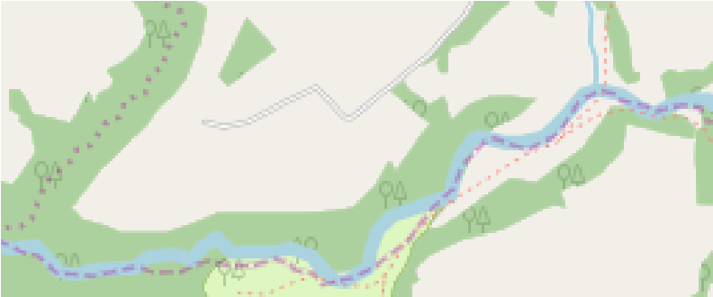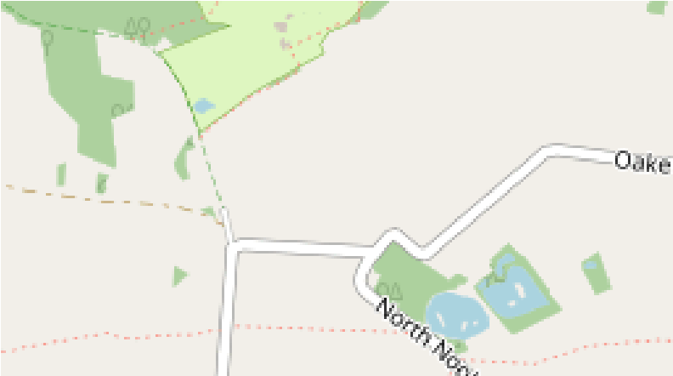

START

Map Data ©

OpenStreetMap Contributors

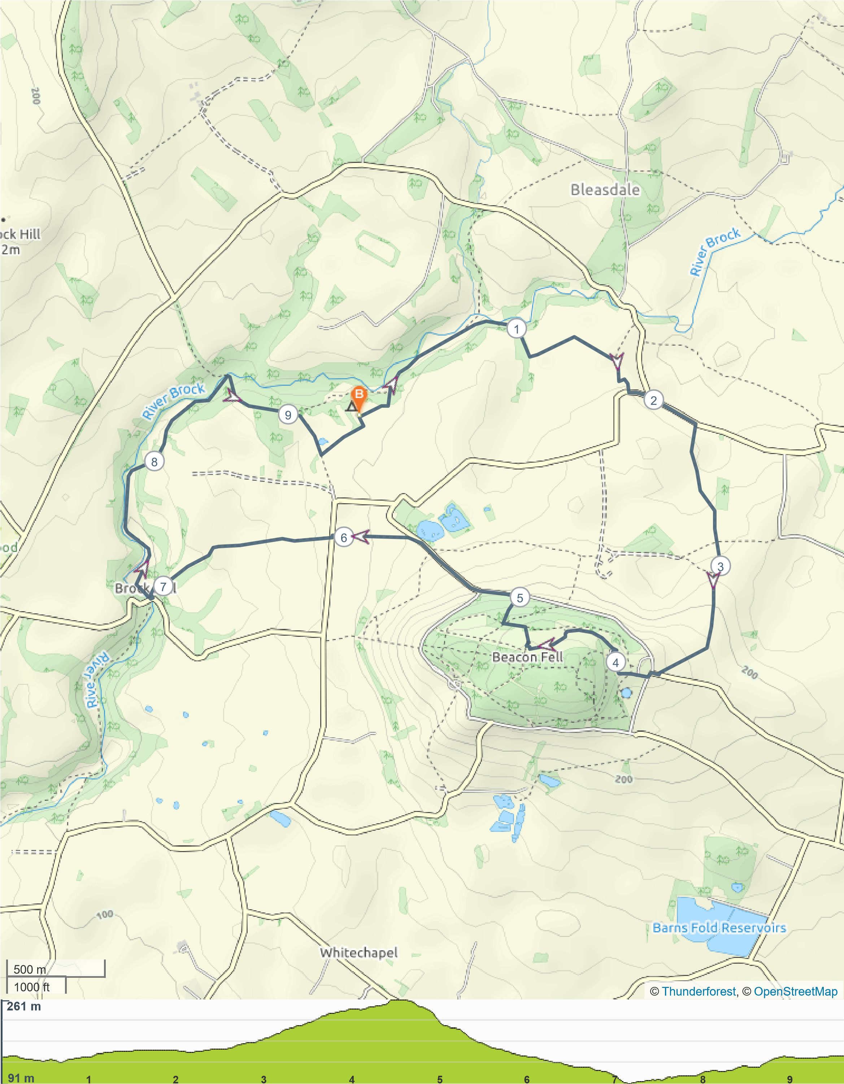

ROUTE DIRECTIONS